# Ideation Phase

**Define the Problem Statements**

|  |  |
| --- | --- |
| Date | 19 September 2022 |
| Team ID | PNT2022TMID29836 |
| Project Name | Customer Care Registry |
| Maximum Marks | 2 Marks |

# Customer Care Registry:

Customer care is a way of dealing with customers when they interact with your brand, products, or services to keep them happy and satisfied. Customer care goes beyond customer service and support because it focuses on building emotional connections between brands and customers.

This Application has been developed to help the customer in processing their complaints. The customers can raise the ticket with a detailed description of the issue. An Agent will be assigned to the Customer to solve the problem. Whenever the agent is assigned to the customer, they will be notified with an email alert. Customers can view the status of the ticket till the service is provided.

Customer can register for an account. After the login, they can create a complaint with a description of the problem they are facing. Each user will be assigned an agent. They can view the status of their complaint.

The main roles and responsibilities of the admin is to take care of the whole process. Starting from Admin login followed by the agent creation and assigning the customers complaints. Finally, he will be able to track the work assigned to the agent and notification will be sent to the customer.

The main use of this project is to help the customer in processing their complaints. The customers can raise the ticket of their issues and the problem will be solved by the organization.

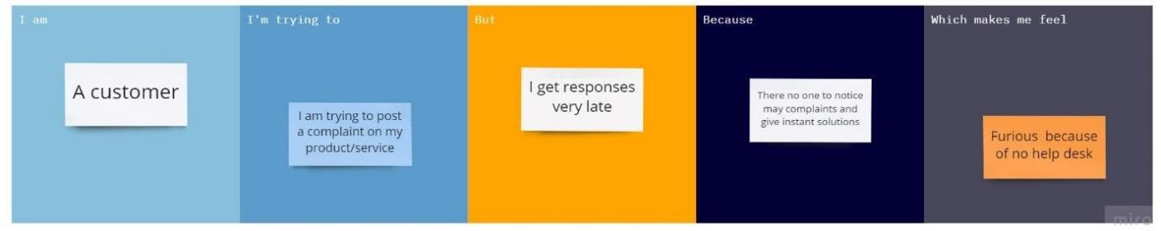

|  |  |  |  |  |  |
| --- | --- | --- | --- | --- | --- |
| **Problem Statement**  **(PS)** | **I am (Customer)** | **I’m trying to** | **But** | **Because** | **Which makes me**  **feel** |
| PS-1 | A  customer | Post a complaint on my Product/ Service. | I get responses very late | There is no one to notice my complaints and give instant solution. | Furious, because of no help desk. |